LOCAL SEACOAST NH USBC AWARDS

Each bowler will receive one award per category per year. Ask your league secretary to submit requests for your awards!
Award | Average Requirement
150 -199 Game-Ice Scraper | 0-130 Average
200 -249 Game-Koozie | 0-155 Average
250-299 Game- Flashlight Bottle Opener | No Average Requirement
400 – 499 Series Towel | 0-125 Average
500-599 Series Towel | 0-150 Average
600-699 Series Towel | 0-175 Average
700-799 Monogrammed Towel | No Average Requirement
800-899 Monogrammed Towel | No Average Requirement
Clean Sweep Ice Cooler | No Average Requirement
100 Over Series Water Bottle | No Average Requirement

GAME AWARDS

150-199 Game- 200-249 Game 250-299 Game
ICE SCRAPER KOOZIE FLASHLIGHT BOTTLE OPENER
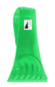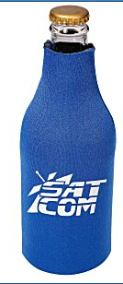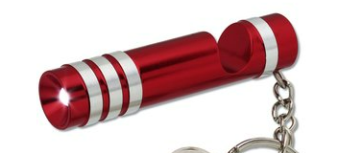

High Series Towels- (Colors may vary )

400-499 Series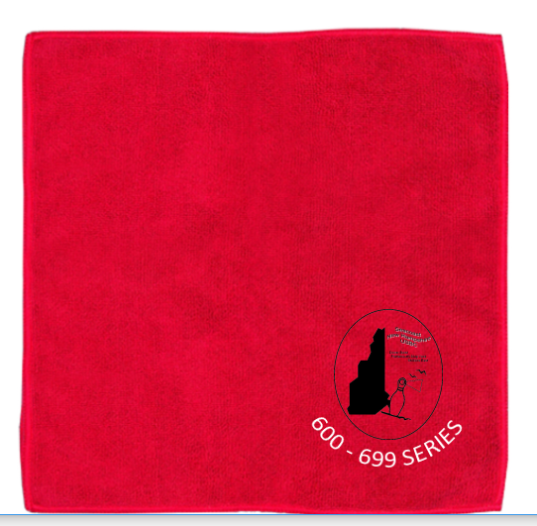 500-599 Series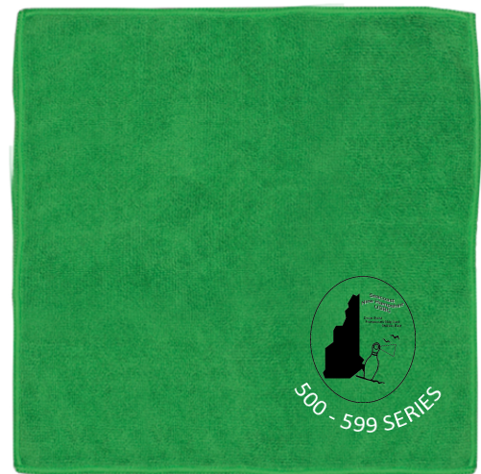

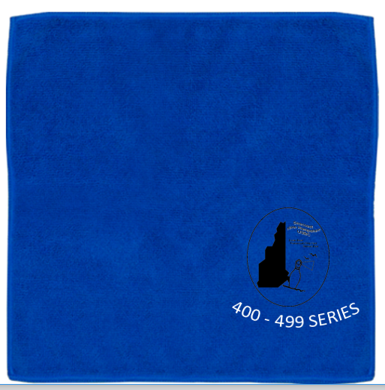600-699 Series

700-799 Series -Monogrammed 800-899 Series-
Towel Monogrammed Towel
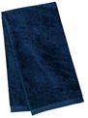

100 Pins Over Avg Series CLEAN SWEEP SERIES- ICE COOLER
WATER BOTTLE
